Appointmnt Scehdulieng Chatbot
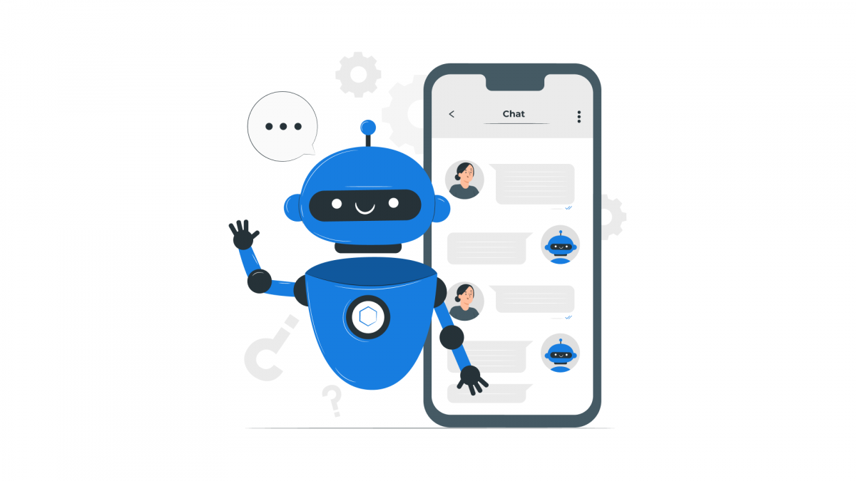

Name : Alan T Sunny

Batch Name : AI

Project Name: Appointment scheduling chatbot

Date : 15/07/2024

INTRODUCTION :
In today’s fast-paced world, efficient and convenient scheduling of appointments is essential for both businesses and their clients. Introducing our state-of-the-art appointment scheduling chatbot, a revolutionary tool designed to simplify the booking process. This chatbot leverages cutting-edge natural language processing (NLP) technology to understand and respond to user requests, making the interaction smooth and intuitive. Users can easily provide their name and contact information, select the type of service they require, and choose from a list of available dates and times. Once the appointment is scheduled, the chatbot confirms the details and sends automated reminders to ensure appointments are not missed. Additionally, the chatbot integrates seamlessly with popular calendar services, offering real-time availability and synchronization. With a focus on secure data handling and user convenience, our appointment scheduling chatbot transforms the traditional booking experience, making it more efficient and user-friendly.

Project Objective :
An appointment scheduling chatbot aims to streamline and automate the process of booking appointments. The key objectives of such a chatbot include:
1. 24/7 Availability: Ensure users can schedule appointments at any time, regardless of business hours.
2. User-Friendly Interface: Provide an intuitive and straightforward interface for users to book, reschedule, or cancel appointments.
3. Automated Reminders: Send automated reminders and notifications to users about upcoming appointments to reduce no-shows.
4. Calendar Integration: Sync with various calendar systems (e.g., Google Calendar, Outlook) to check availability and avoid double bookings.
5. Personalization: Offer personalized scheduling options based on user preferences and past interactions.
6. Real-Time Updates: Provide real-time updates on appointment availability and status.
7. Multi-Channel Support: Operate across multiple platforms, including websites, mobile apps, and messaging services like WhatsApp, Facebook Messenger, and SMS.
8. Data Security and Privacy: Ensure that user data is protected and comply with relevant privacy regulations.
9 .Analytics and Reporting: Offer insights and reports on appointment trends, user behavior, and system performance to help improve services.
10. Customer Support Integration: Connect users to human support when necessary, ensuring a seamless transition from bot to human agent.
These objectives aim to improve user experience, increase efficiency, and reduce the administrative burden on businesses.
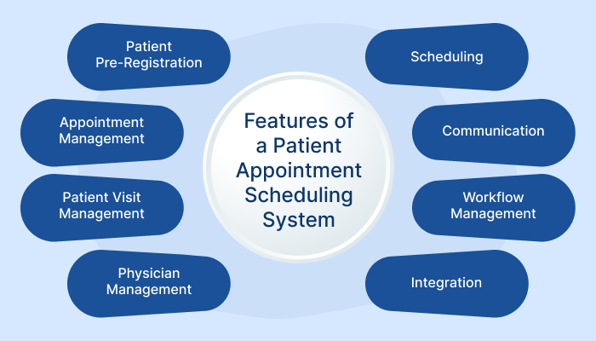

CONTENTS:

1.Introduction
  - Overview of the project
  - Objectives of developing the appointment scheduling chatbot
  - Importance and benefits of implementing the chatbot
- User Requirements and Use Cases
  - Identification of target users (patients, clients, customers, etc.)
  - Analysis of user needs and expectations for scheduling appointments
  - Use cases detailing how different types of users will interact with the chatbot
- System Design
  - Chatbot platform selection (e.g., Dialogflow, IBM Watson, custom solution)
  - Architecture overview (flowchart or diagram showing interaction pathways)
  - Integration details with existing systems (calendar APIs, CRM systems)
- Functional Requirements
  - Features and functionalities the chatbot will offer (e.g., appointment booking, rescheduling, cancellation)
  - Handling of multiple appointments and conflicts
  - User authentication and data privacy considerations
- Technical Implementation
  - Detailed explanation of the chatbot development process
  - Coding languages and frameworks used (e.g., Python, Node.js)
  - Integration with Natural Language Processing (NLP) for understanding user intents and entities
- User Interface Design
  - Chatbot interface design considerations (conversational UI)
  - Mockups or wireframes of the chatbot interface
  - Accessibility and usability considerations
- Testing and Evaluation
  - Testing methodologies (unit testing, integration testing, user acceptance testing)
  - Evaluation criteria (accuracy of booking, user satisfaction)
  - Iterative improvements based on testing feedback
- Deployment
  - Deployment strategy (cloud hosting, on-premises)
  - Rollout plan and timeline
  - Post-deployment monitoring and support plan
- Documentation
  - User guide for interacting with the chatbot
  - Technical documentation for developers and administrators
  - Maintenance plan and updates roadmap

- Conclusion
  - Summary of achievements and challenges faced during the project
  - Future enhancements and scalability considerations
By including these project contents, you ensure a comprehensive approach to developing an appointment scheduling chatbot that meets user expectations, integrates smoothly with existing systems, and provides a seamless user experience.

STEP 1 :-
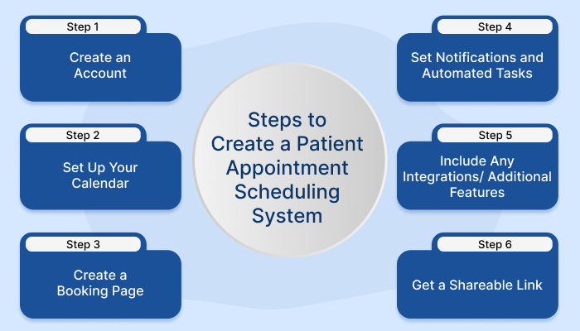
STEP 2 :-
